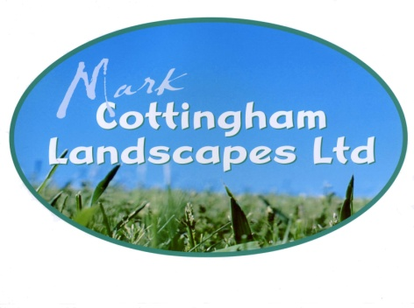
Quality first–for the perfect garden

Mark Cottingham Landscapes Ltd
Review form

Please fill in blank boxes below and email back to mcl1@live.co.uk

Personal Information
First Name: |  |  |  |  |  | Last Name:
Contact Number: |  |  |  |  | Email:
Address:
County: |  |  |  |  |  |  |  | Postcode:
Review
Please rate the following out of 5 where 5 is very good and 1 is very poor
Value for money: |  |  |  | / 5
Speed of job: |  |  |  | / 5
Quality of work: |  |  |  | / 5
Professionalism: |  |  |  | / 5
Overall Rating: |  |  |  | / 5

Further Comments

Mark Cottingham Landscapes Ltd.
12 Easter Way, South Godstone, Surrey RH9 8HQ
Tel: 01342893202 Mob: 07817951040 Email: mark@cottinghamlandscapes.co.uk www.cottinghamlandscapes.co.uk
Directors: Mr. M E Cottingham. England and Wales Company, No.6535388. VAT Reg. No. 940 4729 22.

